10% ans. female  90% ans male | 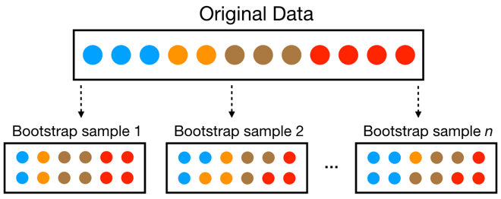 | Adoption rate  0.63
… | …
90% ans. female  10% ans male |  | Adoption rate  0.53

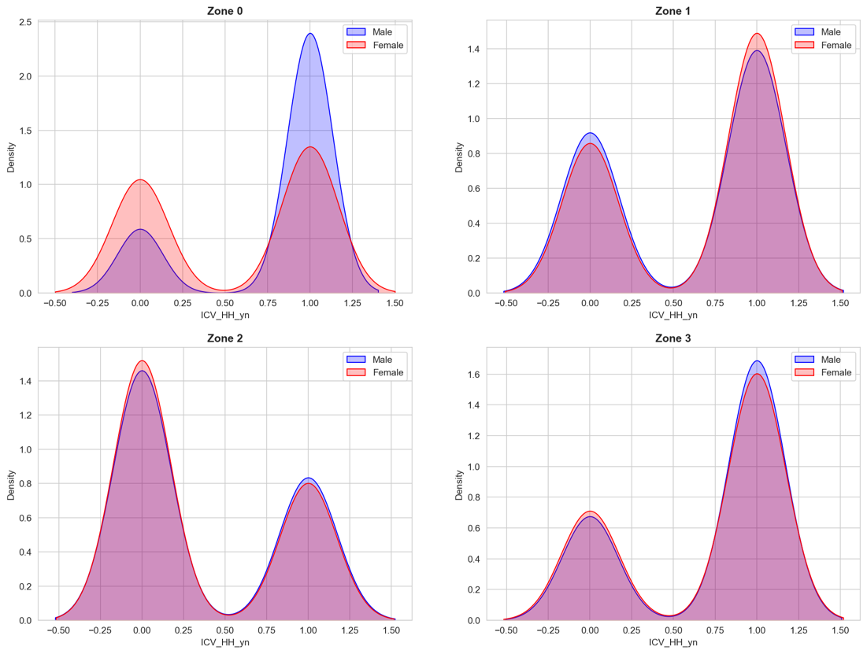
- How big should be n? 100
- The bootstrap should be stratified (consider the zone)? Do both

Correlated Non-Classical Measurement Errors, ‘Second Best’ Policy Inference, and the Inverse Size-Productivity Relationship in Agriculture
Kibrom A. Abay,* Gashaw T. Abate, Christopher B. Barrett, and Tanguy Bernard

- True values of production and land area $Y^{*}=θX^{*}+ε$, where $E\left[Xε\right] = 0$.
- Error-ridden self-reported measures, $Y$ and $X$:
$$Y= Y^{*}+u$$
$$X= X^{*}+v$$
- The standard estimated relationship between partial productivity, expressed as crop yield (production/area), and area cultivated is (typically augmented by a vector of controls omitted here for the sake of focus):
where $β≡θ-1.$
- They analyze the effects of alternative forms of non-classical measurement errors in either production or area on the $β$.
  - Case 1: Measurement error in the dependent variable correlated with true value of the dependent variable:
Then,
  - Case 2: Measurement error in dependent variable correlated with true value of independent variable:
Then,
  - Case 3: Measurement error in independent variable correlated with true value of independent variable:
Then,
  - Case 4: Measurement errors in both dependent and independent variables are correlated:
$$cov\left(u, v\right)= π ≠0$$
Then,
- Summary of Analytical Results
Source of NCME | Key Parameters |  |  |  | OLS estimator of SPR | Bias (assuming β≤0)
No error | 0 | 0 | 0 | 0 |  | No bias
Error in production | <0 | 0 | 0 | 0 |  | Positive/attenuation*
Error in production | ≤0 | ≤0 | 0 | 0 |  | Negative/exaggeration
Error in plot size | ≤0 | 0 | ≤0 | 0 |  | Ambiguous
Error in both | ≤0 | ≤0 | ≤0 | 0 |  | Ambiguous
Correlated error in both | ≤0 | ≤0 | ≤0 | >0 |  | Ambiguous

Notes: we rely on our data and the existing literature (cited in the main paper) to suggest the likely sign of the key parameters of interest. The parameter δ reflects the association between output measurement error and true output, per case 1. The parameter λ reflects the association between output measurement error and true plot size, per case 2. The parameter α reflects the association between area measurement error and true plot size, per case 3. And the parameter π reflects the covariance between output and area measurement error, per case 4.
* Assuming 0>δ>-1, as is generally true in measurement error studies.

* Corresponding author at k.abay@cgiar.org. Affiliations: Abay: International Livestock Research Institute; Abate: International Food Policy Research Institute (IFPRI); Barrett: Cornell University; Bernard: IFPRI and University of Bordeaux.

